THE PARTNERS FOR HEALTH FOUNDATION AWARDS THE BRIDGE, INC. $75,000 TO SUPPORT THE PEACE MODEL PROJECT

For Immediate Release

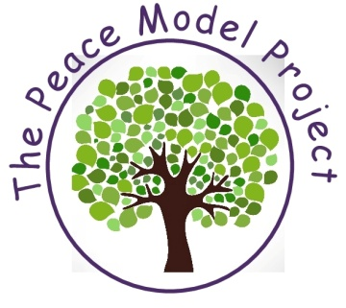
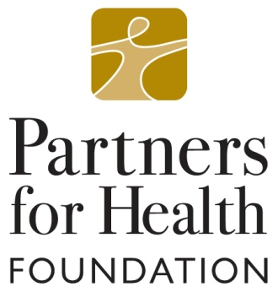
August 21, 2017

Contact:
Debbie Micchelli
Director of Administration

973-228-3000 x318
debbie@thebridgenj.org
www.thebridgenj.org

The Partners for Health Foundation has awarded $75,000 to The Bridge, Inc. to support The Peace Model Project, a school-based mental health & wellness program serving the Caldwell-West Caldwell School District.

The Peace Model Project is a collaborative venture between The Bridge, Inc. and the Caldwell-West Caldwell School district designed to fully integrate community mental health services in four elementary schools. The vision for the project was inspired in response to increased school violence across the nation and growing awareness that mental health intervention in the elementary years can promote emotional resilience and decrease mental health risk factors in adolescence and beyond. Launched in 2015 with funding from the US Department of Education, The Peace Model Project enters its third year of development in the 2017-18 academic year.

“The Caldwell - West Caldwell Schools have been working with The Bridge for over forty years. Our most recent collaboration on the Peace Model Project has been highly successful,” commented James Heinegg, superintendent of the Caldwell-West Caldwell School District. “It is helping our students become healthier individuals, better friends to one another, stronger learners, and more caring members of the community and the world at large. We are very grateful to the Partners for Health Foundation for this generous grant, which will allow us to continue the positive work of the Peace Model Project in the 2017-18 school year and beyond.”

The Bridge, Inc. employs and supports four full-time, credentialed mental health counselors in each elementary school who provide individual & group counseling; parent education; character and community-building curriculum; intervention and referral services.

“We are happy to work with the Caldwell-West Caldwell School district and Partners for Health to build a program that is a model of how community based mental health agencies can work with local schools to promote resiliency in children early in life,” announced Lou Schwarcz, CEO of The Bridge, Inc. “Through The Peace Model Project, we are teaching skills that will help children to achieve their aspirations and prevent future life problems, such as self-harm, harm to others, and substance abuse.”
Categories: News; Education

